Title: | Cloud Infrastructure
Updated: | April 3, 2025 | Due Date: | Midnight before the next class meeting.
Purpose: | The purpose of this lab is to provide hands-on experience with key AWS services such as EC2, S3, and IAM, allowing you to understand the fundamentals of cloud infrastructure management, including launching virtual servers, securing resources, and managing cloud storage.
Knowledge: | After completing this lab, you will have foundational knowledge of managing cloud infrastructure using AWS services such as EC2, S3, and IAM​.
Task/Activity: | A. Launching and Managing EC2 Instances  B. Working with S3 Storage  C. Managing IAM (Identity and Access Management)  D. Configuring Security Groups  E. Reflection
Criteria for Success: | Success in this lab is marked by accurate task completion, effective analysis, documentation, and clear communication of findings. A crucial aspect involves reflecting on the purpose of the lab, linking procedures to broader concepts, and recognizing the lab's significance within the course.  Overall, success is not only measured by technical proficiency but also by critical thinking, effective communication, and a reflective summary that captures the challenges faced and insights gained throughout the lab experience.
- Launching and Managing EC2 Instances
Amazon EC2 (Elastic Compute Cloud) provides scalable computing capacity in the AWS cloud. In this section, you will learn how to create and manage an EC2 instance, which is a virtual server running on AWS. An EC2 instance can be used to host websites, run applications, or perform various compute tasks.
Log into your AWS Academy account and navigate to the AWS Management Console. In the "Services" tab, search for EC2 and click to open the EC2 dashboard.
- Click on "Launch Instance" to start the process of creating a virtual machine.
- Choose the Amazon Linux 2 AMI from the Amazon Machine Image (AMI) dropdown as your operating system. This is a lightweight, secure Linux image optimized for AWS.
- For instance type, select t2.micro, which qualifies for the free tier and provides enough resources for beginner tasks.
- For security purposes, ensure that a key pair is created. This will allow you to SSH into your instance later. Download the key pair file (usually .pem), as it will be needed to access the instance. If you would like, you can use the existing key that you created in the Linux lab.
- In the configuration settings, leave the default network and subnet options. These defaults are sufficient for your EC2 instance.
- Security groups act as a virtual firewall for your EC2 instance. Set up a security group with rules that allow SSH (port 22) access from your IP address, and HTTP access (port 80) if you plan to run a web server.
- Launch the instance. It may take a minute or two for your instance to be ready. While it initializes, observe its status in the "Instances" section of the EC2 dashboard. The instance's state will shift from "Pending" to "Running" when it is ready.
- Once running, click on your instance, and choose "Connect." On the next screen, scroll down to the “Connect” button and click it. This should open a terminal window in the browser, bypassing the need for an SSH client connection.
Once connected, you will have access to a Linux terminal. From here, you can install software, upload files, or perform tasks directly on the instance.
- After launching the EC2 instance, connect via SSH and run basic Linux commands (e.g., uname -a, df -h) to verify the instance is working properly.
# uname -a ß This shows the name, operating system version, and other information about your system
# df -h ß This shows the file systems and available space on them
Paste screenshot with output from these commands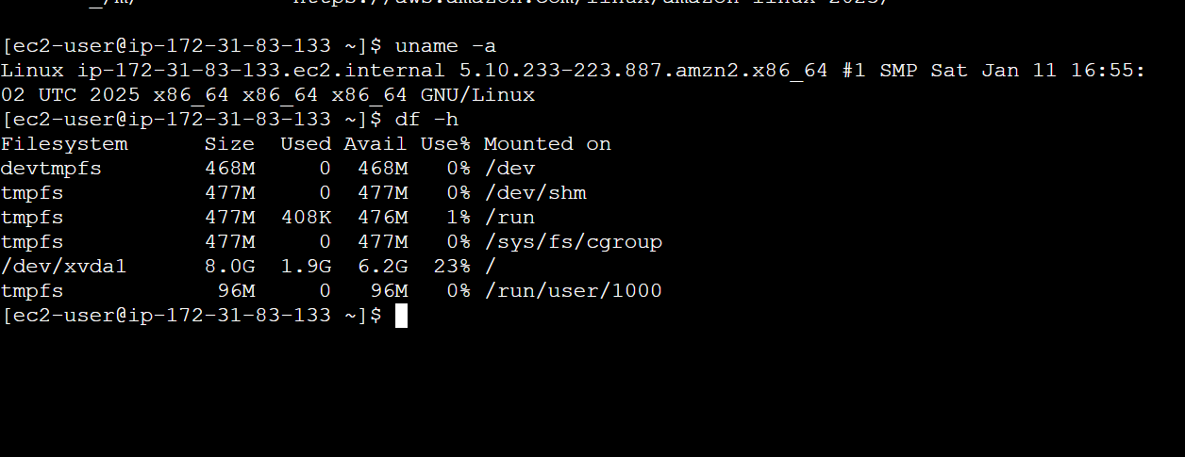
- Use the command sudo yum install httpd (note that this Amazon Linux version uses yum instead of dnf, but works the same) to install the Apache web server, then start the service with sudo systemctl start httpd. Navigate to the instance’s public IP or DNS address in a browser to confirm that the server is running. You can get this information in the AWS EC2 information. You should see the Apache test page.
Paste test page screenshot 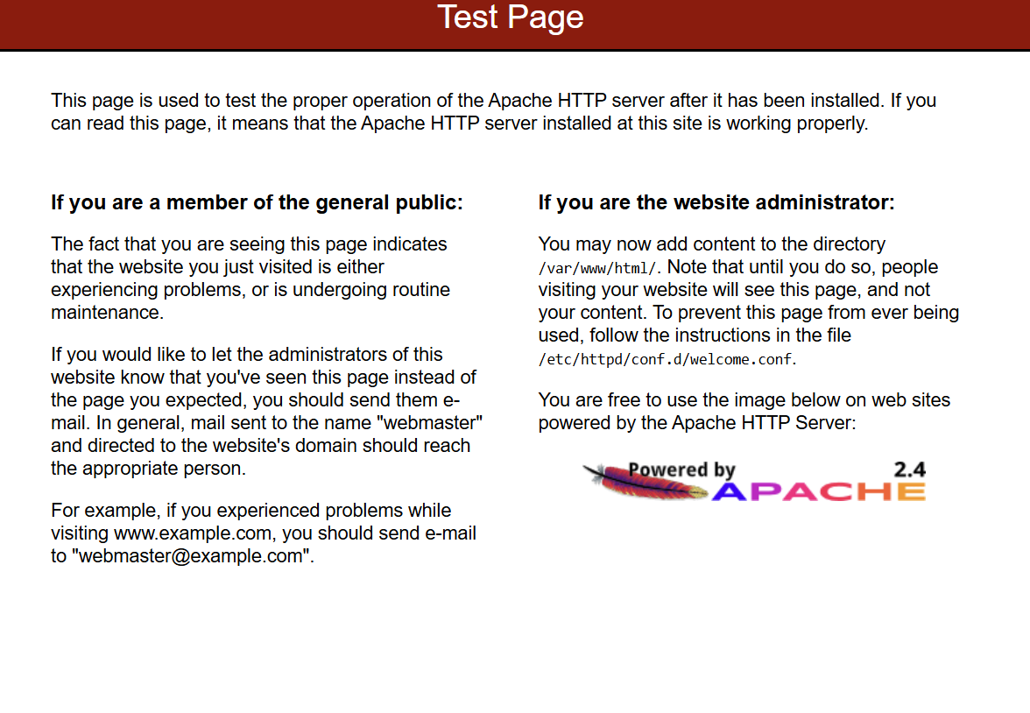
- Shut down the instance with the command sudo poweroff when finished to avoid unnecessary charges.
- Working with S3 Storage
Amazon S3 (Simple Storage Service) is a highly scalable and durable object storage service. S3 is commonly used for data backup, static website hosting, and storing large volumes of data. In this section, you will learn how to create S3 buckets, upload data, and manage access permissions.
- From the AWS Management Console, search for S3 and navigate to the S3 dashboard.
- Click “Create bucket” and provide a unique name for your bucket.
- Leave most settings at their default, but under Block Public Access Settings, uncheck the options to allow public access to the bucket (useful for web hosting). This will require you to check the “I acknowledge that the current settings might result in this bucket and the objects within becoming public” option.
- Keep the other default settings and click “Create bucket” at the bottom.
- Once your bucket is created, click on its name to open it, then click “Permissions” along the top. Even though we allowed public access, we must modify the bucket policy to allow anyone to have access. Scroll down to “Bucket policy” and click “Edit” on the right. Paste in the below, making sure to change the “YOUR_BUCKET_NAME” to match the name of your bucket.
{
"Version": "2012-10-17",
"Statement": [
{
"Effect": "Allow",
"Principal": "*",
"Action": [
"s3:GetObject"
],
"Resource": "arn:aws:s3:::YOUR_BUCKET_NAME/*"
}
]
}
Scroll to the bottom and click “Save changes.”
- Click on “Objects” near the top and select "Upload," then “Add files” in the top right of the bucket upload screen to add files from your local machine. Try uploading a simple text file or image. Scroll to the bottom and click “Upload.” Scroll to the top and click “Close.”
- Click on file that you just created under “Objects.” Click the “Copy URL” button for the object and test access in your browser. Note that you will have to open an incognito or private browser window to properly test this. If permissions are correctly configured, you should be able to view the file (or download the file if it can’t be viewed in the browser) publicly.
- Select the “Properties” tab to change the settings of the bucket. Click “Edit” next to Bucket Versioning and enable versioning on your S3 bucket to keep multiple versions of files. This feature is useful for backup purposes, allowing you to restore earlier versions of objects. Click “Save changes.”
- Create a text file with the following contents:
This is the first version of my file.
- Save the file as version.txt and upload it to your bucket.
- Edit the file again to add:
This is an edit to the file to test versioning.
- Upload this file to your bucket.
- Click on the version.txt file in your S3 bucket. Select the “Versions” tab at the top. Submit a screenshot of your versions.
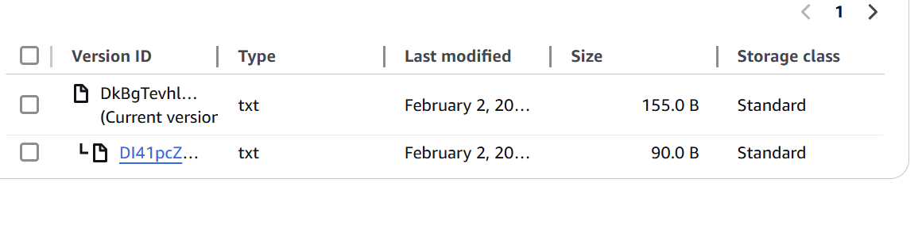
Now, it is time for you to practice these steps:
- Create a new S3 bucket called lab04. Be sure to allow public access.
- Upload several files to your S3 bucket and retrieve their URLs. Paste the URLs below. This should be 3-4 total.
https://lab-0-4.s3.us-east-1.amazonaws.com/Strawberry-cat.png
https://lab-0-4.s3.us-east-1.amazonaws.com/strawberry-kitty.png
https://lab-0-4.s3.us-east-1.amazonaws.com/thumbnail_1000005910.jpg
https://lab-0-4.s3.us-east-1.amazonaws.com/thumbnail_1000006057.jpg

- Change the access settings on your bucket (B.5 above) to be publicly accessible, and verify by accessing the URL in a private browser window.
Screenshot of file 
- Enable versioning on your bucket and upload a modified version of an existing file. Submit a screenshot of the versions screen.
Screenshot of versions 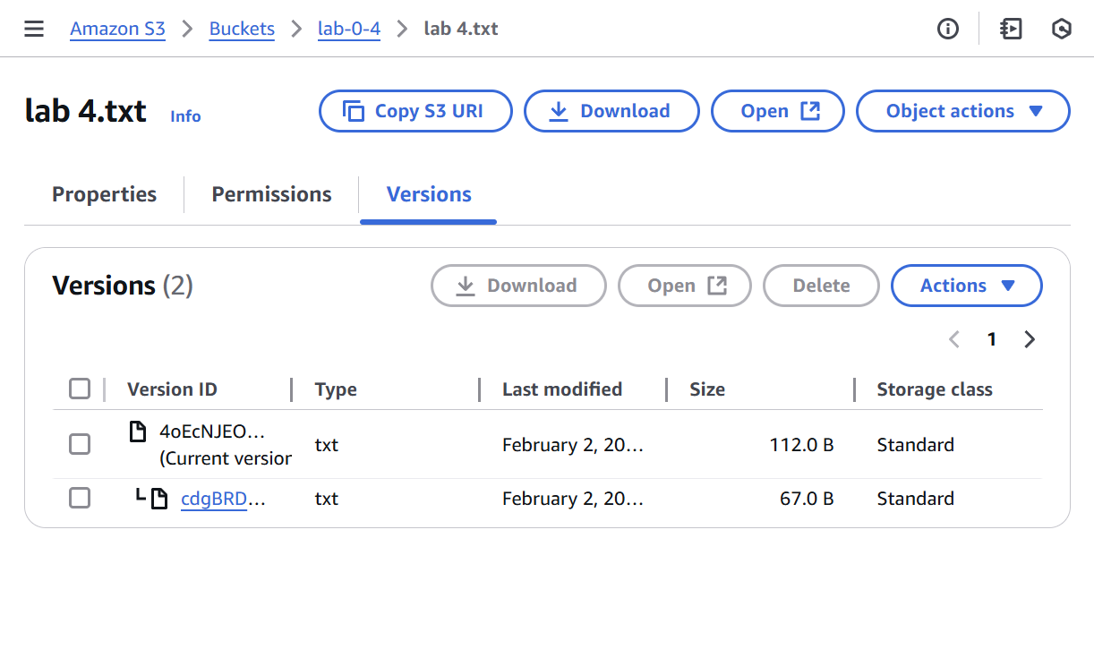
- Select the previous version of the file and click the “Open” button. Do the same for the “Current version.” Submit both as screenshots.
Original Version | Current Version
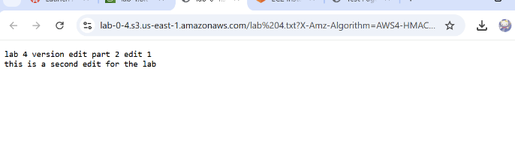 | 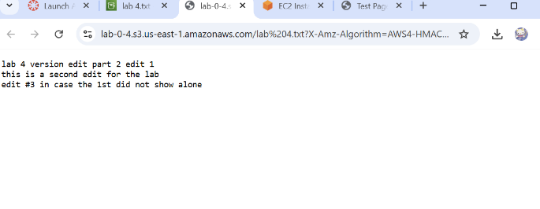
- Managing IAM (Identity and Access Management)
AWS IAM (Identity and Access Management) allows you to manage access to AWS services securely. You can create and manage users, groups, and roles, and define permissions to control who can access what in your AWS environment. In this section, you will create IAM users and policies to secure access to AWS resources.
- Navigate to IAM in the AWS Management Console.
- Choose “Users” and then “Add User.” Create a user with console access. In the future, you may need to create a user with programmatic access (needed for API/CLI access) for an application or tool you are using/creating.
Note: If you selected programmatic access, AWS will generate an Access Key ID and Secret Access Key. Store these securely, as they will allow the user to access AWS resources via the AWS CLI or SDK.
- Choose custom password and set a secure password. Uncheck the “Users must create a new password at next sign-in” to not require the change. Click “Next”.
- The user needs permissions assigned. For this example, select “Attach policies directly.” AWS has a lot of pre-created policies that will take care of the heavy lifting in many cases. For this exercise, attach the "AmazonS3FullAccess" policy under “Permissions policies” to give the user full access to S3. Note: You can search for “S3” to narrow down the options.
Click “Next,” then “Create user” at the bottom.
Note: You will get an error at this point because the lab environment doesn’t allow user creation. This is ok. You have the experience now of creating a user with permissions.
- Configuring Security Groups
Security Groups in AWS act as virtual firewalls to control incoming and outgoing traffic to your EC2 instances. Understanding how to configure these correctly is vital to securing your infrastructure.
- Navigate to the EC2 Dashboard and click on the instance ID of the server you created back in part A of this lab. Copy the public IPv4 address on the instance summary.
- Connect to the web console as you did in step A.8.
- In the console, type:
# ping {the IPv4 address you copied in step 1}
After 4-5 seconds, hit CTRL + C to cancel ping. Your pings should have failed with 100% packet loss.
Paste screenshot of failed pings here 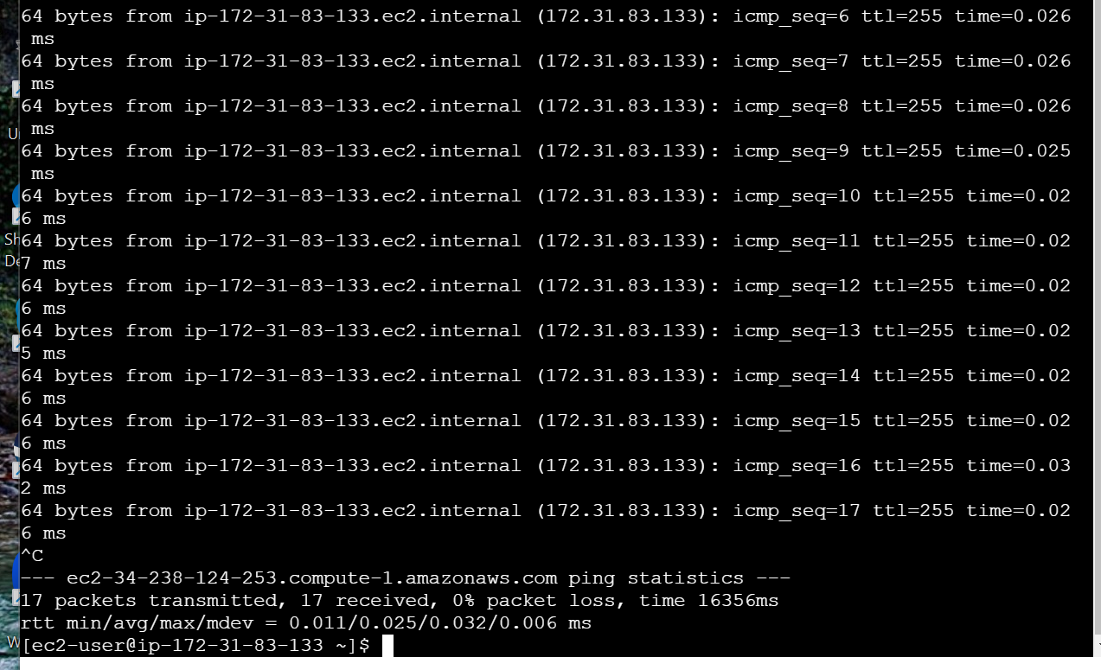
- Leave this tab with the console open, and navigate to the EC2 Dashboard in another tab and click on “Security groups.” Find the security group associated with your EC2 instance. Usually, this will be “launch-wizard-2” for this lab. To be sure, navigate to the instance list, click on the instance ID of the server you created back in part A of this lab, scroll down and select the “Security” tab, then click on the security group listed.
- Click “Edit inbound rules,” then “Add rule” to add a new rule. Select “All ICMP – IPv4” to allow your server to respond to pings. Select “Anywhere – IPv4” from the source drop down. Click “Save rules.”
- Go back to the tab with the console open and try the ping command again. It should be successful. To end the pings, hit CTRL + C.
Paste screenshot of successful pings here 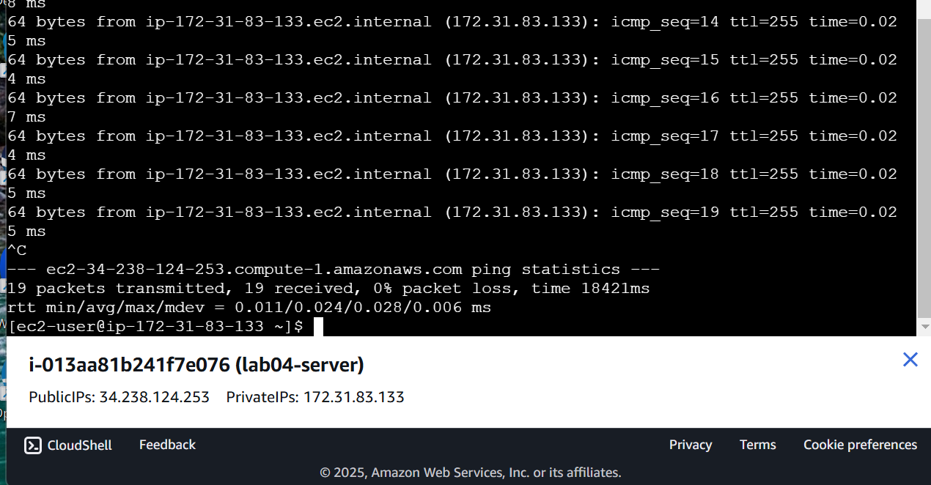
- Reflection
Reflect on your experience managing cloud infrastructure using AWS services in this lab. Consider the challenges you faced while launching and managing EC2 instances, configuring S3 storage, and setting IAM permissions. How did these tasks help you understand cloud resource management, and how might this knowledge apply to real-world scenarios in cloud computing?
The directions of this lab are incredibly detailed, though I am still a bit confused on the importance of each step, but I know that with more practice I will come to be confident in the process. I must also say that it was pretty fun to see the application of AWS is a different form, and I look forward to exploring the variety of processes it has to offer.

